Topic: Comparison of stock market performance among the US and Chinese tech companies, with respect to the Impact of the Covid-19 Pandemic

Student Name: Wong Chuen Lik Daniel  
Student Number: 210763720Supervisor Name: William Marsh  
Programme of study: MSc in Computing and Information System

*Abstract* - This research contains findings about the different responses of stock performance in the US and Chinese markets. It aims to analyze the impact of Covid-19 on stock markets based on the total number of new cases. Several literature reviews about macroeconomics and stock data modellings, such as linear regression and time series modelling were included in this report. An exploratory data analysis about the stock market performance has also been covered in this report. This project incorporated different datasets such as the stock prices, Covid-19 new cases, a composite index of government responses against Covid-19 (OxCGRT), CPI, and unemployment rate. Both the classical learning model (Polynomial Regression & SVR) and time series model (ARIMA) have been used to predict the stock prices and evaluated against their performance. The results reveal that SVR with good parameters outperforms other traditional models. We also find that incorporating macroeconomic factors improve the forecast performance of the classical learning models, indicating the significance of macroeconomic factors since the emergence of the pandemic.

# Introduction

## The Covid-19 Pandemic

Considering the economic and geographical disparities between different countries worldwide, there is a growing concern about the contradictory status between the US and China in terms of their differentiation in the political system and public policy against Covid-19 (Coppock, 1974). Therefore, for the sake of wiser investment strategy and decision, it is worth exploring the relationship between the Covid-19 pandemic and the stock market in respect to the stock market performance in US and China.

## How technology changed our lives in the pandemic

The emergence of new technologies has changed our ways of living after the covid-19 pandemic. Numerous technology companies have benefited immensely from the pandemic lockdown and “work from home” (WFH) dynamic, which adopted innovative technology to survive and embrace the challenges along with the pandemic. For examples, Zoom and Netflix, the leading companies in video communication and streaming service, boomed during the pandemic due to the increasing demand of virtual meeting and video streaming service. Whilst our human behaviours shifted from physical to online, we are also using extensive technologies in our life.

## Emerging of Chinese tech companies and the negative impact of the pandemic

China is emerging rapidly and having more influential power on the global economic and technological development. China’s major tech companies, so-called BATX (Baidu, Alibaba, Tencent and Xiaomi), are consistently challenging the prominent position of US tech giants in the market, so-called FAANG (Facebook, Apple, Amazon, Netflix and Google). Owing to the high demand of massive domestic market and centralized system of government policy, China’s tech companies have grown dramatically in the past decade (Naubahar, 2016). While both American and Chinese big tech firms are facing keen competition in the global market, they are also impacted by the negative consequence due to the outbreak of Covid-19. Efforts to combat this pandemic such as quarantine and travel restrictions have been slowing down the world economy, which shrink by 3.3% in 2020 (The World Bank, 2022). The drop in demand and the global supply chain issues even caused a financial crisis in Mar 2021, with over a 10% slump in Nasdaq 100 Index.

## Aim of the project

This project aims to analyze the relationship between the stock price in tech companies and other factors, as well as to compare the stock market performance between the US and China. Several datasets, such as Covid-19 data, stock prices, index of government responses against covid (OxCGRT), CPI, and unemployment rate have been included in this project. Two composite indexes, namely Nasdaq 100 Index (NDX) and iShares China Lar-Cap ETF (FXI) have been chosen as the target attribute in this project. Different data analytic models have been introduced, implemented, and validated against their effectiveness. The intention of this report is to examine the effects of the Covid-19 pandemic on the stock market and the feasibility of placing external factors as input attributes in stock data modelling.

## Outline of the Paper

The remainder of this paper is structured as follows: Section 2 introduces the economic and technological consequences of the pandemic, followed by the literature review on stock data modelling in Section 3. Section 4 introduces the data sources. Section 5 presents the exploratory data analysis, followed by Sections 6 & 7 presenting the data modelling result in multiple classical learning models and time series model respectively. Finally, we conclude this project and provide recommendations in Section 8.

# Economic and Technological Consequences of the Pandemic

## Macroeconomics in stock market

### Macroecomics situation and Intermarket relationships

Prior to the exploratory analysis about the relationships between stock market performance and other factors, it is crucial to have a basic understanding about macroeconomics.

In contrast of microeconomics, macroeconomics tends to focus on long-term economic growth, which might involve GDP, inflation rate, interest rate, political event, and even the pandemic. Although there is no widespread conclusion that the stock market performance is directly affected by macroeconomics, it is evident that macro-environment still plays a critical role in the global market. For instances, the outbreak of Covid-19 pandemic triggered Nasdaq index to plunge 30% in the New Year of 2020, following with a recession contributed by the announcement of tapering bond purchase and rising interest rate in Nov 2021 (Bloomberg, 2021). Overall, this circumstance tends to pose a negative impact on stock prices as raising interest rate costs company more to borrow and lowers its profits.

Besides, there are sophisticated Intermarket relationships between 4 primary markets, which are commodities, bond prices, stocks, and currencies (Murphy, 2011). For instance, there is an inverse relationship between interest rate and bond prices, and stock will eventually head down if bond prices begin to fall. A summary of those relationships is shown as the table below.

1. summary of intermarket relationship

|  |  |  |  |
| --- | --- | --- | --- |
| Currency:  ⬆️ | Commodities (e.g., crude oil, aluminum, gold):  ⬇️ | Bond Prices:  ⬆️ | Stocks:  ⬆️ |
| Currency:  ⬇️ | **Commodities** (e.g., crude oil, aluminum, gold): **⬆️** | **Bond Prices:**  **⬇️** | **Stocks:**  **⬇️** |

## A comparison of public policy against Covid-19

Different countries such as the US and Chinese governments differ significantly in their public policy decision-making due to cultural and geographical differences. Since the outbreak of the pandemic, China has followed a series of elimination strategies with mass Covid-19 testing and strict lockdown, resulting in a low case number between 2020 to early 2022 (Dennis, 2021). Many manufacturing industries shut down during that period and causing supply chain issues affecting the revenue of tech giants like Apple and Tesla.

In contrast, the public policies against Covid-19 are often less stringent in western countries, leading to a failure in controlling the pandemic (Rebecca & Michelle, 2020). Instead, there has been a rising number of companies adopting flexible or WFH policies to cope with the pandemic.

## Effect of the pandemic on Technology Use

Recently, it has become increasingly evident that the pandemic is accelerating a digitization process that had already started a decade before (Amankwah-Amoah et al., 2021). The prevalence of WFH policy is reshaping our work worldwide, and a wide range of digital technologies have emerged extensively ranging from video conference software to artificial intelligence (Deedra Vargo et al., 2020).

While people are spending more time at home, they are also willing to spend more on online shopping and home entertainment. This made a massive growth in e-commerce platforms like Shopify (US) and PDD (China). As customers are prioritizing online shopping experiences, it introduced a business model called ‘Click and Mortar’, where retailers integrate both online and offline operations to enhance the customer experience (Shopify, 2022). R

Besides, the pandemic has led to the increasing demand of video streaming services and paved a way for live commerce, which is an emerging model combining streaming video and shoppable service into one. It is currently spreading over the world, particular on the Chinese video streaming platform Bilibili. These emerging business models have changed the plays in e-commerce industry, and we can foresee that more technology will be complemented in our post-pandemic lives, which is hastening the digital transformation in long term.

# Literature review

## Lit review on Stock Data Modelling

There has been numerous literature investigated on stock data modelling. Since the 1970s, financial analysts and researchers have started to use machine learning approaches to predict stock prices and their fluctuations. However, prediction of the stock price has always been a difficult task given that there are too many uncertainties in the markets.

The first report to be discussed was written by Salisu & Vo (2020). It studied the prediction of stock returns based on the social media content associated with covid-19 pandemic. It cited two economic theories called ‘price pressure hypothesis’ (Barber & Odean, 2008) and ‘network analysis’ (Nofsinger & Sias, 1999). Those theories supported their hypothesis that individual investors tend to rely on stock information (i.e., news) as they do not have enough time or resources to examine each stock and hence the stock companies capturing investors’ attention usually have abnormal high returns and trading volume. This study provided a solid foundational knowledge for our project to understand the rationale behind the uncertain stock price and investment decisions.

The second article to be discussed was written by Zack West (2021). It demonstrated how to implement a linear regression model by using scikit-learn library to make predictions on stock prices. It used one of the popular technical indicators – exponential moving average (EMA) as the input feature to train the model and validated it accuracy by several metrics (i.e. root mean squared error (RMSE) and coefficient of determination (corr). This study built a foundation for our project as it highlighted the effectiveness of using a regression model in stock price prediction. Also, it inspired us to adopt the technical indicator EMA as a predicting variable in our data modelling.

The third report to be discussed was written by Lucas of (no date). It investigated different applications of regression techniques to predict the stock price and evaluated different models’ success in data modelling. The chosen models included linear regression, Stochastic Gradient Descent (SGD) and Support vector regression (SVR). By comparison, it concluded that support vector regression was the most effective model in stock price prediction theoretically regardless of the potential extra techniques or parameter tuning. This report strengthened our confidence to select polynomial regression and support vector regression in our project, given that both models perform differently in terms of linear and non-linear fitting.

The fourth report to be discussed was written by Ayodele, Aderemi, and Charles (2014). This paper presents a thorough perspective of using the Autoregressive Integrated Moving Average (ARIMA) model in stock price prediction. It demonstrated how the ARIMA model utilizes autocorrelation measures, that are data’s own lags and the lagged forecast errors, to model temporal structures within the time series data. This report highlighted that ARIMA models are robust and efficient in financial time series forecasting and they could even outperform complex models in short-term prediction. Hence, this study established a strong confidence to adopt the ARIMA model as one of the supervised learning models in our project, given its simplicity and popularity.

# Data source

## Summary of data source

This project covers various datasets including Covid-19 data, stock price, Composite index of government responses against Covid-19 (OxCGRT), Consumer Price Index (CPI), and unemployment rate*.* The first three datasets are retrieved fromthe World Health Organization (2022), Yahoo Finance (2022), and Blavatnik School of Government (2022) respectively, whilst the data sources for the US and China’s CPI and unemployment rate include Office for National Statistics (2022), Trading Economics (2022), and Federal Reserve Economic Data (2022). The dataset details are shown in the table below:

|  |  |  |
| --- | --- | --- |
| Data | Data Description | Data Justification |
| COVID-19 | Only the attribute of Covid-19 new cases was extracted, which reflects laboratory-confirmed cases including both domestic and repatriated cases.  Counts were calculated by subtracting previous cumulative total counts from the current count. | According to the official documentation of WHO (2022), all data are subject to variations in case detection, laboratory testing, definitions, and reporting strategies between counties and areas. Hence, those data are still under consideration to cause under or overestimation of true case. |
| *Stock price* | All data are downloaded from Yahoo Finance and shown in daily-basis with closing price. | The 15 and 10 biggest tech companies were chosen in the US and China respectively. |
| Composite index of government responses against Covid-19 (OxCGRT) | The Oxford Covid-19 Government Response Tracker (OxCGRT) collects and tracks different policy responses that governments have taken to cope with COVID-19 since 1 January 2020, covering more than 180 countries. This is a composite measure of 23 indicators, such as school closures, travel restrictions, face covering, vaccination policy, etc. | This dataset is about Covid-19 restriction, which reveals the scale of government policy against Covid-19 (i.e., the number and strictness of government policies). This index is critical as it can reflect the extent of impact brought from the pandemic to the society and businesses in a quantitative way. |
| Consumer Price Index (CPI) | Consumer Price Index (CPI) measures the monthly change in prices paid by citizens. Different countries use different methodologies for calculation, where the U.S. Bureau of Labor Statistics (BLS) calculates the CPI as “a weighted average of prices for a representative basket of goods and services”. | CPI can be deemed equivalent to the inflation rate. It is an indicator playing an important role in economic decision-making including the Federal Reserve's interest rate policy and plans of major banks thus it has a great impact on the stock market. |
| Unemployment Rate | Similar to CPI, unemployment rate is shown in percentage. It is the percentage of the total labor force that is unemployed but are available to work and actively seeking employment. | Rather than GDP, unemployment rate is chosen in this project as GDP is not always an accurate measure of economic growth (World Economic Forum, 2021) and GDP is somehow already reflected on CPI. |

## Justification of chosen companies

The 15 and 10 top tech companies in the US and China were chosen respectively in accordance with their market cap up to July 2022. Owing to the unstable market, the market value of stock companies has fluctuated intensely, especially in recent years. Also, it is difficult to infer the actual value of Chinese tech companies, as the ability of paying tradable goods in China is relatively lower than those in the US, which is about the concepts of international trading and economy. Hence, the value evaluation of the chosen companies based on the market cap might not be accurate as it is hard to tell which company is the ‘biggest’ tech company.

Specific stocks were chosen by groups in the following section, as we intended to compare the market performance of stocks with similar innovative services/products between the US and China. For instance, Tesla and Zoom were chosen as both could represent the leading competitor in the hardware and software industry; Shopify and PDD were chosen instead of the well-known tech giants Amazon and Alibaba, as the former mainly focuses on the e-commerce platform, whereas the latter covers other businesses like cloud computing.

# Exploratory analysis

In this section, we are going to analyze our datasets by data visualization. This is followed by the stock data modelling and recommendations section in this report.

## Aim/Methods

This section aims to explore the relationships between the stock prices of tech companies and other external factors. We have five datasets, including Covid-19 new cases, Covid-19 government response tracker, CPI, unemployment rate and stock prices, with a period of 2 years between Jan 2020 to Apr 2022. The intention of this section is to examine how the number of Covid-19 new cases influenced the price changes on tech stocks in the US and China particularly those that seem to be benefited from the pandemic.

## Data preprocessing

Data preprocessing work, such as data cleaning, data integration, and data transformation, have been done in this project. In which, three main tasks are discussed here, which are data aggregation, log transformation, and stock data indexing.

First, the daily counts of Covid-19 new cases were aggregated into weekly data by using Groupby function, so that the line chart could be smoothed and presents a longer trend more clearly.

Second, as the Covid-19 new cases in China increased dramatically in early 2022, it acted as an outlier and make it difficult to spot the relatively low amount of data in 2020 and 2021 with the same scale. An extreme high variance and a boxplot are shown in Appendix A. Hence, all the data have been transformed by taking a natural logarithm to facilitate the visualization and remove its exponential variance.

Third, all attributes of stock prices were indexed to percentages with a common starting point of 100 as a mean of data normalization. It is known as a common practice used by stock analysts and economists as it can allow investors to observe how variables change over time with different magnitudes and determine the rates of growth in different stocks quickly (Federal Reserve Bank of Dallas, no date).

## Macroeconomic factors

### New Covid-19 Cases in China and the US

A line graph which compares the number of Covid-19 new cases between the US and China is shown in Figure 1. Data aggregation and log transformation were undertaken behind this graph. The graph shows that China had more Covid-19 new cases than the US before Apr 2020 (aka the first wave), and the US overtook China after that (aka the second wave).

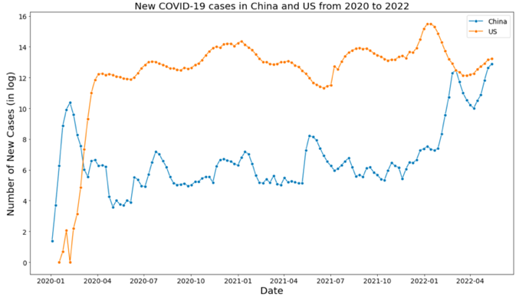

1. Comparison of the number of Covid-19 new cases in the US and China with logged data

### Covid-19 Government Response Tracker (OxCGRT)

The indexes of the Covid-19 Government Response Tracker (OxCGRT) in the US and China were presented as Fig. 17 and 18 in appendix B. It was expected that China has a higher extent of government response against Covid-19 when compared with those of the US. Unfortunately, neither a trend nor an obvious difference between the US and China was observed in the graphs. This may be due to the complexity of the composite index’s matrix. For example, although China has a strict policy against Covid, the local governments and businesses rarely announce or permit people to work from home(WFH) due to the cultural difference, whereas WFH policy is very common worldwide nowadays. Hence, these considerations might appear as a limitation in this project.

### Consumer Price Index (CPI)

A line chart which compares the Consumer Price Index (CPI) between the US and China is shown as Fig. 19 in appendix B. It shows that the US had a lower CPI than China in 2020 until it outpaced China in Oct 2020 and finished at a peak of 8%. This revealed that the inflation rate in the US is more severe than those in China currently, posing inevitable risks to the US financial stability.

### Unemployment Rate

A line chart which compares the unemployment rate between the US and China is shown as Fig. 20 in appendix B. It shows that the US unemployment rate reached a peak in Apr 2020 with over 14%, and then gradually declined over 2 years to finish at below 4%. In contrast, China remains a relative low unemployment rate throughout the two years, with a range of 5 to 6%.

Roughly speaking, a decreasing unemployment rate could represent a growing economy, according to Okun’s Law (Okun, 1962). The result exposes the truth to us that the US’s economy was indeed greatly impacted by the Covid-19 pandemic during the outbreak, whereas China’s economy was not affected seriously. As discussed in section II, it may be associated with the rapid government response and stringent public policy against Covid-19.

## Overview of Stock market prices

### Stock price change in the 15 biggest US tech companies

A summary of the stock price changes in the 15 biggest US tech companies is shown as Fig. 21 in appendix B. It shows that Tesla has the best performance among all tech companies reaching a tenfold increase in a year, followed by Zoom with an approximately 800% growth rate in Oct 2020. The details will be discussed as follows.

### Stock price change in the 10 biggest Chinese tech companies

A summary of the stock price changes in the 10 biggest Chinese tech companies is shown as Fig. 22 in appendix B. We can observe that the top three stock companies are Bilibili, Meituan, and PDD respectively. Again, the details will be discussed as follows.

## Comparison of stock price change by groups

### Zoom vs Tesla

Two stocks, Tesla and Zoom, have undertaken unwavering growth throughout these 2.5 years, as shown in Figure 2. Tesla has succeeded in these years owing to its wise business strategy and advanced technologies far ahead of others, whilst Zoom has been benefited due to the WFH policy and hybrid working mode nowadays. Zoom is a great example who enjoyed plenty of benefits from this pandemic and its growth was accelerating along with the pandemic. Still, Zoom can't avoid the inevitability to move downward after 2022.

1. Comparison of stock price change: Zoom vs Tesla

### Shopify vs PDD

A comparison of two emerging e-commerce companies, namely Shopify (the US) and PDD (China), is shown in Figure 3. As discussed in section II, both of them solely focus on online shopping platforms and extensively benefited from the Covid-19 pandemic, which help them to reach approximately 450% and 350% growth in Mar 2021 respectively.

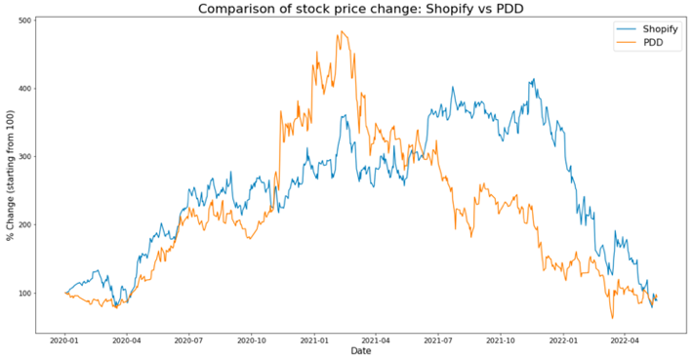

1. Comparison of stock price change: Shopify vs PDD

### Netflix vs Bilibili

Whilst Netflix has become a household video streaming service across the world, a Chinese company called Bilibili is also capturing investor insight. Bilibili, which is a prevalent streaming service platform in China, is dominating the Chinese local market. As shown in Figures 4 & 6, Bilibili had a jump and went beyond other growing companies during the pandemic reaching a peak of 700% in Feb 2021, whereas Netflix had a brief rise until Dec 2021 and then started declining due to the keen competition in streaming market and saturated growth of subscriber in early 2022 (Fortune, 2022).

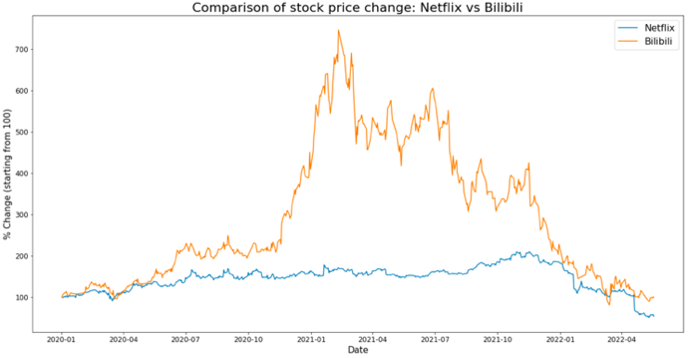

1. Comparison of stock price change: Netflix vs Bilibili

## Comparison of Covid-19 new cases and stock prices

Figures 5 & 6 illustrate a comparison of Covid-19 new cases and the largest tech stock prices in the US and China from 2020 to 2022, with two different scales (indicated with green and brown colors respectively).

The first graph of the US market shows that the tech stock prices have diverged along with the high level of covid-19 new cases, and most of them even started declining in Nov 2021. It revealed that the COVID-19 pandemic has posed a negative impact on the US stock market due to a multitude of reasons. Another ETF indicator called FNGU, which covered the 10 biggest American tech companies such as FAANG, has performed much better than Nasdaq 100 index during the pandemic. But still, most of the tech giants have been enduring unprecedented challenges due to supply chain issues.

Likewise, the second graph shows a significant diversion in the Chinese tech stock market along with the fluctuating new cases. For instance, Trip.com, a Chinese multinational online travel company, was experiencing a slump in the market due to the low demand for travelling, whereas several stocks such as Bilibili, Meituan, and PDD were performing extraordinary in this pandemic. The latter companies refer to the prevailing video streaming service, food and grocery delivery, and emerging online shopping platform in China respectively. Apparently, these industries have grabbed the opportunities and exploited the benefits of this pandemic.

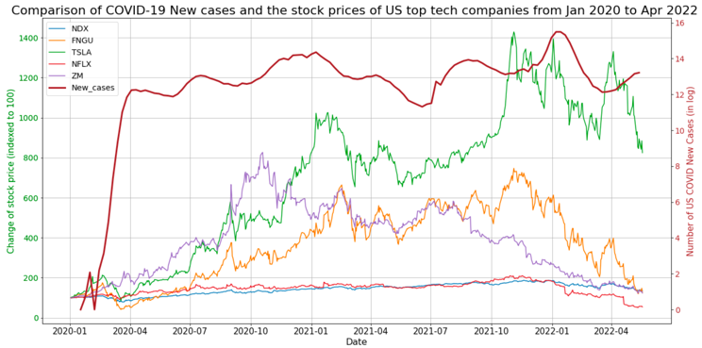

1. Comparison of the US Covid-19 new cases and the stock prices of US top tech companies from Jan 2020 to Apr 2022

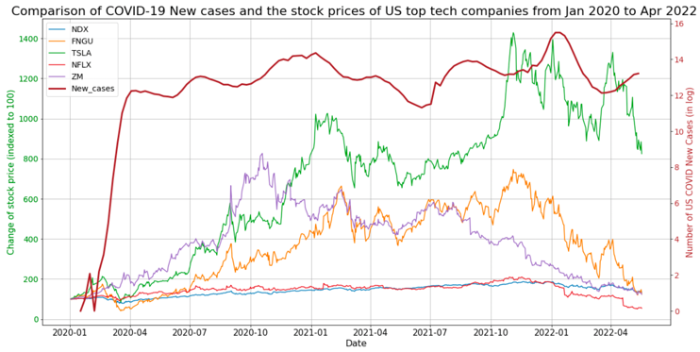

1. Comparison of China’s Covid-19 new cases and the stock prices of Chinese top tech companies from Jan 2020 to Apr 2022

## Comparison of CPI and stock prices

### The US’s CPI vs its stock price

According to Okun's law (1962), there is a negative relationship between economic output and unemployment. While high inflation is generally considered harmful, some economists believe that a small amount of inflation can help drive economic growth (Board of Governors of the Federal Reserve, 2020). Roughly speaking, an increasing inflation rate (CPI) and decreasing unemployment rate could imply a healthy growth trend in the country's economy.

As shown in the graph, the US unemployment rate reached a peak at 15% and then dropped continuously since Apr 2020, while the CPI has been increasing constantly since Apr 2021. Hence, it is anticipated that the US has a growing economy, and the majority of stock prices should align with it. Notwithstanding, both Nasdaq 100 index (the 100 largest non-financial companies listed) and FNGU (the 10 biggest US tech companies) have been growing upward from Apr 2020 to Dec 2021, and then dropped dramatically due to the current “hard landing” policy (tapering and rising interest rates).

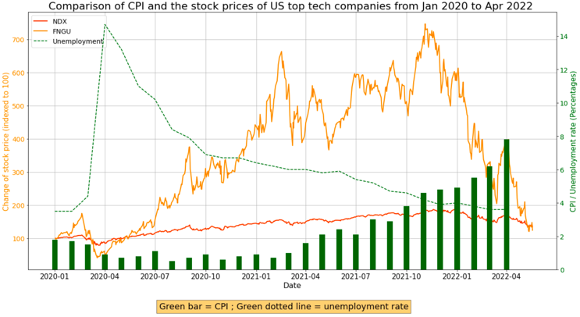

1. Comparison of the US’s CPI, unemployment rate, and tech stock prices from Jan 2020 to Apr 2022

### China’s CPI vs its stock price

In opposite, China has a relatively low inflation rate (CPI) and high unemployment rate, especially after Apr 2021. While the unemployment rate in China maintained constant between 5-6%, its CPI hit rock bottom as a negative percentage (-1%) which implies a deflation environment for a short period of time. However, the stock market of Chinese top tech companies has gone quite well during the pandemic. As shown in the graph, two ETFs namely FXI (which covers an array of Chinese tech and financial companies) and KWEB (mainly composed of China Internet companies), have undertaken a fantastic journey throughout the pandemic, reaching peaks at approximately 120% and 190% in Feb 2021, yet returned to only 60% and 75% in Apr 2022 respectively.

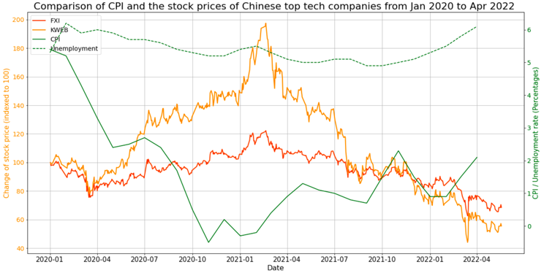

1. Comparison of China’s CPI, unemployment rate, and tech stock prices from Jan 2020 to Apr 2022

To sum up, despite the divergence of market performance in different sectors and countries, it is evident that both markets in the US and China have gone through a long journey up and down along with the Covid-19 pandemic throughout these 2.5 years. The following sections will introduce stock data modelling in order to explore the effectiveness of using macroeconomic factors as our predicting attributes in stock price prediction.

# Classical learning modelling

## Aims and Justification

This section aims to implement and evaluate the effectiveness of classical models by utilizing the macroeconomic factors as input attributes, so as to provide an alternative model selection in stock price prediction. As discussed in the literature review, Polynomial Regression and Support Vector Regression (SVR) are specifically chosen in this project as the classical learning models. Both models are well-known supervised learning algorithms to estimate relationships between two or more quantitative variables. Although these traditional models may not have the best performance for time series, they can still be adopted if the seasonality of time series can be extracted and put into a variable (Joos Korstanje, 2021).

## Setup

In advance, a python library called Sklearn is imported, and a variable namely EMA_10 is created to act as one of the predicting attributes. It is an exponential moving average (EMA) measuring trend direction with the previous 10 days whereas more weight is placed on the most recent data points.

The data modelling will be implemented twice in two datasets, the US and China. Both datasets have the input attributes with EMA_10, Covid-19 new cases, OxCGRT, CPI, and unemployment rate, where the target attributes were chosen as Nasdaq 100 index (NDX) and iShares China Large-Cap ETF (FXI) respectively.

First, to create a polynomial regression model, we need to determine the degree of polynomial features where it is set as 2 here. A typical 2nd-degree polynomial formula is shown as equation 1, and it is assumed that our actual formula will be much longer as we have 5 independent variables, which is shown in equation 2.

y = ax2 + bx + c (1)

NDX = a(EMA_10)2 + b(EMA_10) + a(CPI)2 + b(CPI) + a(New_cases)2 + b(New_case) + … + c (2)

The second step is to split the data into training and test data. We preserved the order of time series rather than randomly shuffling the data as our time series data contains an upward trend which is shown as Figure 23 in appendix C. Here we split the train and test data in a proportion of 8:2.

Once the data are transformed into polynomial features and split into training and test data, we can initialize and fit them into data modelling by calling linear regression and SVR, where the coding is shown below.

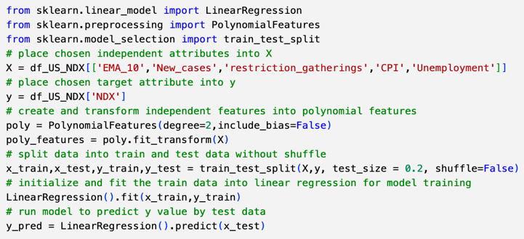

## Evaluation metrics of model performance

Five indicators were used to evaluate the model performance, which include RMSE, R2, correlation coefficient, time series split cross-validation, and blocked cross-validation.

The first performance indicator is Root Mean Squared Error (RMSE). It is widely used to measure the quality of predictions. Simply put, a lower RMSE is preferred, as zero RMSE means perfect prediction in the model.

The second and third performance indicators intend to examine the model performance regarding the coefficient of determination (R2) and the correlation coefficient between the actual and predicted value (corr).

The fourth and fifth performance indicators used the cross-validation method, as it can avoid overfitting problems. It has been proposed as a standard approach for time series evaluation by Christoph & Jose M (2012).

## Results

### A Correlation among all key attributes

A correlation heatmap was visualized to find out the correlation between the target attribute (NDX/ FXI) and independent attributes, which is shown in Figure 9. It shows that the US’s CPI has a positive correlation with NDX, whereas both countries’ unemployment rate has a negative correlation with the target attribute (i.e., NDX, FXI). It is aligned with our assumptions above, as a low unemployment rate represents a healthy economy, which usually reflects on a growing stock market performance.

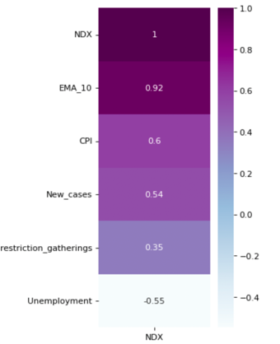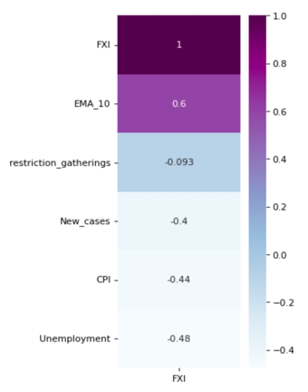

1. Correlation matrix in the US and China (left = the US; right = China)

### Model Performance

Four models have been trained, evaluated, and compared in this section. It includes simple linear regression, polynomial regression, and SVR with ‘linear’ and ‘RBF’ kernel. In which, ‘linear’ kernel is used when the data is linearly separable, where ‘RBF’ (i.e., radial basis function) kernel is the default kernel used in support vector machine (SVM) classification.

The result of the first model - simple linear regression is shown as Fig. 27 in Appendix C. There is no surprise that it shows a poor result, as simple linear regression is assumed to be used with one predicting attribute for better performance.

The result of the second model - polynomial regression is shown in Figure 10, where red line indicates the actual price and blue line indicates the predicted price. It shows a better result than simple linear regression, with 7.758 RMSE and 0.8 corr. However, this result should not be considered a good performance as it has large negative scores in cross-validation and the visualization of actual price diverged significantly.

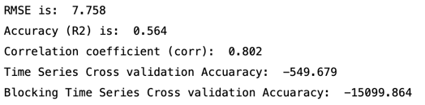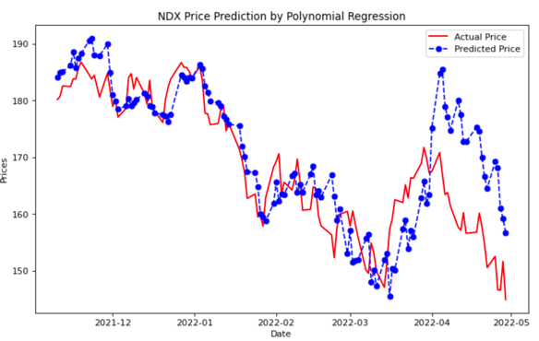

1. Result of Polynomial Regression (blue = observed, red = predicted)

The result of the third model – SVR with linear kernel is shown as Fig. 28 in Appendix C. Overall, it performs better than polynomial regression and simple linear regression, but still, it has a negative score in both cross-validation metrics.

The result of the fourth model – SVR with ‘rbf’ kernel is shown in Figure 11. It shows an outstanding result with the best performance among all models discussed in this section. It has a low RMSE (3.777) and a high correlation coefficient (0.952). Also, the scores in both cross-validation metrics are positive, implying this model can also work well on past data.

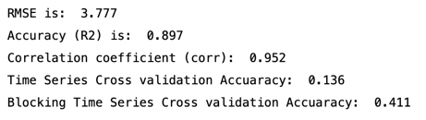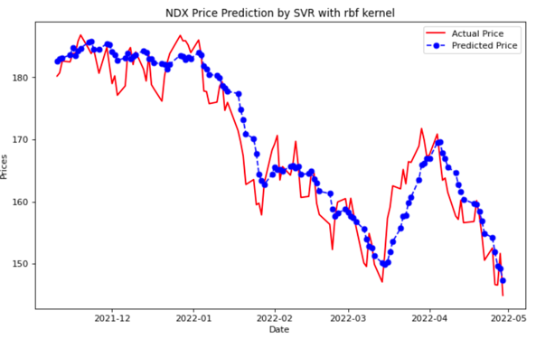

1. Result of SVR with ‘rbf’ kernel (blue = observed, red = predicted)

Interestingly, when we solely use EMA_10 as the input attribute and compare its results, it was found that the accuracy of our proposed models (polynomial regression and SVR with ‘rbf’ kernel) is even better than the latter. In other words, the effectiveness of stock price prediction will be further boosted if we integrated the macroeconomics factors as our predicting attributes. Nevertheless, the simple linear regression and linear SVR models performed better with the unique input EMA_10, which still makes sense in mathematics as linear regression usually work better with univariate input attribute. The result of SVR with ‘rbf’ kernel is shown as Figure 12 and the results of other models are shown in Appendix C.

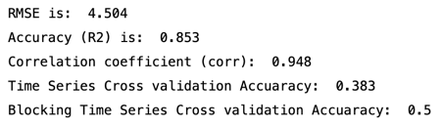

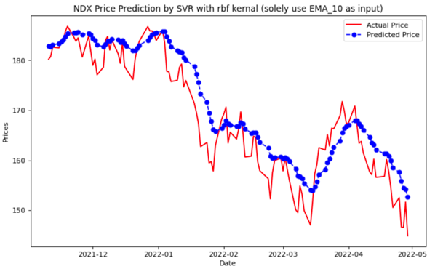

1. Result of SVR with ‘rbf’ kernel when solely using EMA_10 as input

Similarly, the implementation of stock price prediction has been done in China dataset. The graphs and associated coding can be found in Appendix C and F respectively.

# Time series modelling

## Aims and Justification

This section aims to implement and validate the effectiveness of the prevalent time series model as a comparison with the classical models that were implemented above. The Autoregressive Integrated Moving Average (ARIMA) model has been chosen in this project, as it has been proved as one of the most prominent methods in financial forecasting and addressing time series mathematical problems (Ariyo et al., 2014; Box et al. 2015).

Although we have used regression models to analyze the relationships between the dependent variable (EMA_10) and other independent variables in the previous section, it is not always the case that we can use linear regression models to analyze time series, given that it is non-stationary data.

ARIMA is a time series model to predict future values based on previously observed values including its own past values and past error. As the name suggests, it integrated two models – Auto-Regressive (AR) and Moving Average (MA) model. The output values of AR model depend on a weighted linear equation of its past values (own lags), whilst the output values of MA model depend on the errors made by the previous model (i.e., AR model). The mathematical equations of AR and MA models are shown as below. In which, ⍺ is the interception, β1 is the coefficient of lag1, Zt is the white noise of data, and φ*1* is the lagged forecast error.

Yt = α + β1Yt-1 + β2Yt-2 + ... + βpYt-p + Zt (2)

*Yt = α + Zt +* φ*1Zt-1 +* φ *2Zt-2 + ... +* φ *p* φ*t-p*(3)

## Setup

ARIMA model is defined by three parameters – p, d, q, where p, d, and q denote the number of lagged observations, the number of differencing for raw data, and the size of the moving average window respectively.

There are numerous approaches to find out the optimal ARIMA parameters. A classical approach called Box-Jenkins Methodology proposed by George & Gwilym (1970) was followed in this project. Simply put, we have validated the correlation and model performance with the aid of Autocorrelation function (ACF) plots and summary statistics.

As an autoregressive model essentially is a linear regression, it is necessary to ensure that the time series data is stationary, by using differencing in ARIMA. By visualising the ACF plots, we could identify the trend and autocorrelation in data and thus determine the degree of differencing (d).

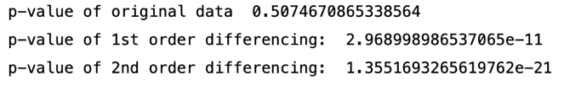

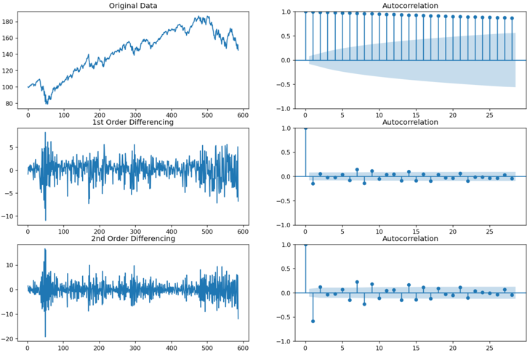

1. Visualisation of data distribution and autocorrelation in original data, 1st order differencing data, and 2nd order differencing data

Next, a model summary provides several statistical information about the model performance where we could utilize the scores in Akaike Information Criteria (AIC) and p-value to determine the goodness of the model. Simply put, the p-value should ideally be less than the significance level of 0.05 and a lower AIC is always preferred. As discussed above, the output of moving average (MA) model purely depends on the output made by the autoregressive (AR) model, thus we have to determine the number of lag (p) and the size of moving average window (q) by different comparisons of pairing.

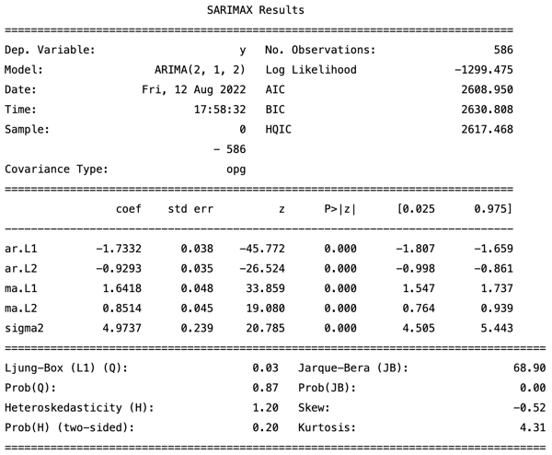

1. A statistic summary of ARIMA result with the parameters (2,2,1)

Lastly, we reviewed the residual plot to verify whether all the data fit well into the model, which is shown as Fig. 37 in Appendix D.

Alternatively, we can call the function auto_arima() from the ‘pmdarima’ package to search for the best parameter with a stepwise approach, shown as Fig. 38 in Appendix D.

As the result, we set the ARIMA parameters for the US dataset and China dataset as (2,1,2), and (2,1,0) respectively.

## Results

A comparison of the predicted price and actual price of NDX is shown in Figure 15. Apparently, it shows an excellent result with a very low RMSE (3.102) and a high correlation coefficient (0.965). Likewise, the result in the China dataset even performed better. However, the graph only presents the price prediction within the period in test data, as it is difficult to forecast into the future which is unknown due to the scope of this project.

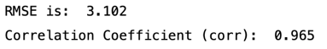

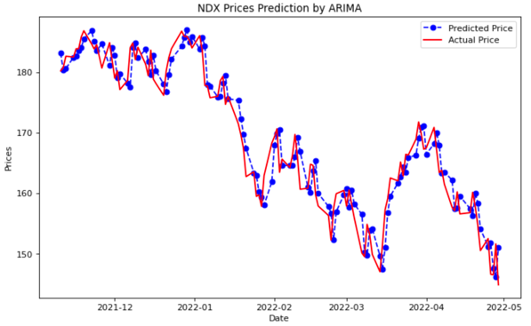

1. The result of ARIMA model in NDX price prediction

# Conclusion & recommendations

Overall, extensive works of literature have been reviewed and summarized and it was found that there are sophisticated relationships behind the stock market particular in this uncertain environment. Real-life financial forecasting is often more complicated than the relationships described in the exploratory analysis section, but these depict a full picture of how the various actors play in the process of economic decision-making.

Upon evaluating the effectiveness of different machine learning models, it was found that the stock forecasting performance can be explicitly enhanced by placing macroeconomics factors as predicting attributes in classical learning models, including polynomial regression and SVR with the ‘RBF’ kernel. Despite the ARIMA model still beating the classical models, it provided a compelling insight and an alternative solution in stock price modelling.

Regarding the limitations, it is indeed challenging to establish a robust model in stock price prediction, as the future is inherently unpredictable given the current unstable environment. When it comes to real-life investment decisions, more factors might need to be considered, such as the financial ratio of stock (e.g., P/E, P/S, D/E), technical indicator (e.g., MACD, KDJ), market emotion, behavioural psychology, etc.

After all, the power of the ARIMA model could be potentially leveraged by including seasonality and exogenous factors (i.e., SARIMAX), whilst more advanced techniques and tools could be adopted in future research, such as deep learning, neural network and XGBoost.

# references

1. Amankwah-Amoah, J., Khan, Z., Wood, G., & Knight, G. (2021). COVID-19 and digitalization: The great acceleration. Journal of business research, 136, 602–611. <https://doi.org/10.1016/j.jbusres.2021.08.011>
2. Ariyo, A. A., Adewumi, A. O., & Ayo, C. K. (2014). Stock price prediction using the ARIMA model. In 2014 UKSim-AMSS 16th international conference on computer modelling and simulation (pp. 106-112). IEEE.
3. Barber B.M., Odean T (2008). All that glitters: The effect of attention and news on the buying behavior of individual and institutional investors. Review of Financial Studies. 2008;21:785–818
4. Blavatnik School of Government (2022). Available at: <https://www.bsg.ox.ac.uk/research/research-projects/covid-19-government-response-tracker> (Accessed: 5 Aug 2022)
5. Bloomberg UK (2021). November 2021 Fed Interest Rate Decision. Available at: <https://www.bloomberg.com/news/articles/2021-11-03/fed-to-start-tapering-asset-buys-by-15-billion-later-this-month#xj4y7vzkg> (Accessed: 8 Aug 2022)
6. Box, G. E., Jenkins, G. M., Reinsel, G. C., & Ljung, G. M (2015). Time series analysis: forecasting and control. John Wiley & Sons.
7. Christoph Bergmeir, Jose M. Benitez (2012). On the use of cross-validation for time series predictor evaluation. doi: 10.1016/j.ins.2011.12.028
8. Coppock, J. T. (1974). Geography and Public Policy: Challenges, Opportunities and Implications. Transactions of the Institute of British Geographers, 63, 1–16. <https://doi.org/10.2307/621525>
9. Deedra Vargo, Lin Zhu, Briana Benwell, Zheng Yan (2020). Digital technology use during COVID-19 pandemic: A rapid review. doi: 10.1002/hbe2.242
10. Federal Reserve Bank of Dallas (no date). Indexing Data to a Common Starting Point. Available at: <https://www.dallasfed.org/research/basics/indexing.aspx> (Accessed: 5 Aug 2022)
11. Federal Reserve Economic Data (2022). Unemployment. Available at: [https://fred.stlouisfed.org/series/UNRATE#](https://fred.stlouisfed.org/series/UNRATE) (Accessed: 5 Aug 2022)
12. Fortune (2022). ‘Dark clouds are gathering for the streaming industry’: Experts say that Netflix catastrophe could mean sector-wide fallout. Available at: <https://fortune.com/2022/04/22/netflix-losing-subscribers-streaming-industry-saturated-market/> (Accessed: 9 Aug 2022)
13. George Box, Gwilym Jenkins (2015). Time Series Analysis: Forecasting and Control (Wiley Series in Probability and Statistics). 5th Edition. ISBN-10: 1118675029.
14. Lucas Nunno (no date). Stock Market Price Prediction Using Linear and Polynomial Regression Models. Available at: <http://www.lucasnunno.com/assets/docs/ml_paper.pdf> (Accessed: 29 Jul 2022)
15. Murphy, J. J. (2011). Intermarket analysis: profiting from global market relationships. John Wiley & Sons.
16. Naubahar Sharif (2016). China as the World’s Technology Leader in the 21st Century: Dream or Reality? HKUST IEMS Thought Leadership Brief No. 11. Available at: <https://iems.ust.hk/publications/thought-leadership-briefs/china-as-the-worlds-technology-leader-in-the-21st-century-dream-or-reality>
17. Nofsinger J.R., Sias R.W (1999). Herding and feedback trading by institutional and individual investors. The Journal of Finance. 1999;54(6):2263–2295. doi: 10.1111/0022-1082.00188.
18. Normile, Dennis (2021). "'Zero COVID' is getting harder—but China is sticking with it". Science. 374 (6570): 924. doi:10.1126/science.acx9657. ISSN 0036-8075.
19. Office for National Statistics (2022). Available at: <https://www.ons.gov.uk/economy/inflationandpriceindices/timeseries/l55o/mm23> (Accessed: 5 Aug 2022)
20. Okun, Arthur M. (1962). "Potential GNP: Its Measurement and Significance," American Statistical Association, Proceedings of the Business and Economics Statistics Section.
21. Rebecca L. Haffajee, J.D., Ph.D., M.P.H., and Michelle M. Mello, J.D., Ph.D. (2020). Thinking Globally, Acting Locally — The U.S. Response to Covid-19. DOI: 10.1056/NEJMp2006740
22. Salisu, A. A., & Vo, X. V. (2020). Predicting stock returns in the presence of COVID-19 pandemic: The role of health news. International Review of Financial Analysis, 71, 101546. <https://doi.org/10.1016/j.irfa.2020.101546>
23. Shopify (2022). What is a Brick and Mortar Store & Should I Have My Own? Available at: <https://www.shopify.com/retail/brick-and-mortar#3> (Accessed: 7 Aug 2022)
24. The World Bank (2022). Dataset in GDP growth (annual %). Available at: <https://data.worldbank.org/indicator/NY.GDP.MKTP.KD.ZG> (Accessed: 11 Aug 2022)
25. Trading Economics (2022). China Inflation Rate. Available at: <https://tradingeconomics.com/china/inflation-cpi> (Accessed: 5 Aug 2022)
26. Trading Economics (2022). China Unemployment Rate. Available at: <https://tradingeconomics.com/china/unemployment-rate> (Accessed: 5 Aug 2022)
27. World Economic Forum (2021). GDP is no longer an accurate measure of growth. So what can take its place? Available at: <https://www.weforum.org/agenda/2021/05/gdp-new-measure-economic-growth/> (Accessed: 5 Aug 2022)
28. World Health Organization (2022). WHO Coronavirus (COVID-19) Dashboard. Available at: <https://covid19.who.int/data> (Accessed: 5 Aug 2022)
29. Yahoo Finance (2022). yfinance 0.1.74. Available at: <https://pypi.org/project/yfinance/> (Accessed: 5 Aug 2022)
30. Zack West (2021). Predicting Stock Prices with Linear Regression in Python. Available at: <https://www.alpharithms.com/predicting-stock-prices-with-linear-regression-214618/> (Accessed: 29 Jul 2022)

# appendices

This appendices shows all remaining graphs and tables in the exploratory analysis and data modelling, followed by the codes and notes about the data visualization and data modelling.

**Appendix A – Data preprocessing**

1. Variance of the attribute covid-19 new cases

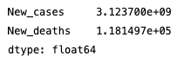

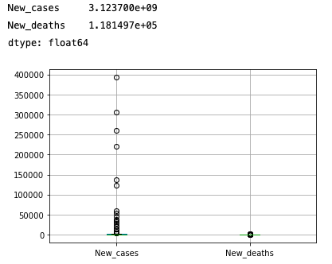

1. A box chart to show the scale of values in covid-19 new cases

**Appendix B – Graphs of Exploratory Analysis**

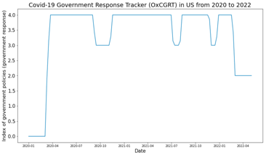

1. Covid-19 Government Response Tracker (OxCGRT) in the US

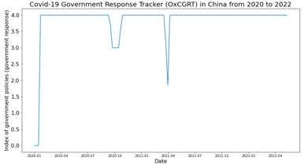

1. Covid-19 Government Response Tracker (OxCGRT) in China

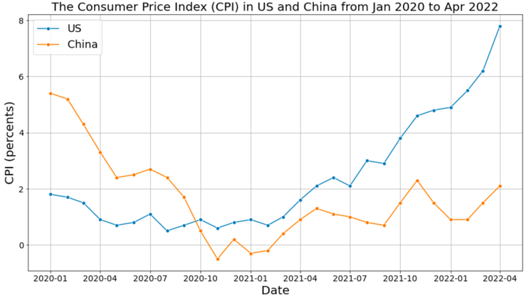

1. Comparison of the Consumer Price Index (CPI) in the US and China

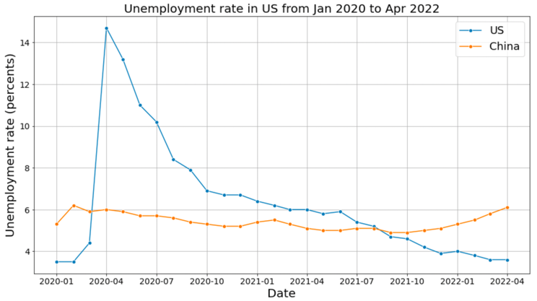

1. Comparison of the Unemployment rate in the US and China

1. A summary of stock price change in the 15 biggest US tech companiesfrom Jan 2020 to Apr 2022

1. A summary of stock price change in the 10 biggest Chinese tech companiesfrom Jan 2020 to Apr 2022

**Appendix C – Graphs of Classical Learning Modelling**

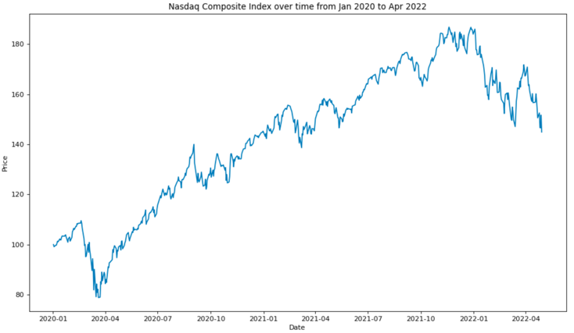

1. A plot of the Nasdaq 100 index over time showing an upward trend with non-stationary data

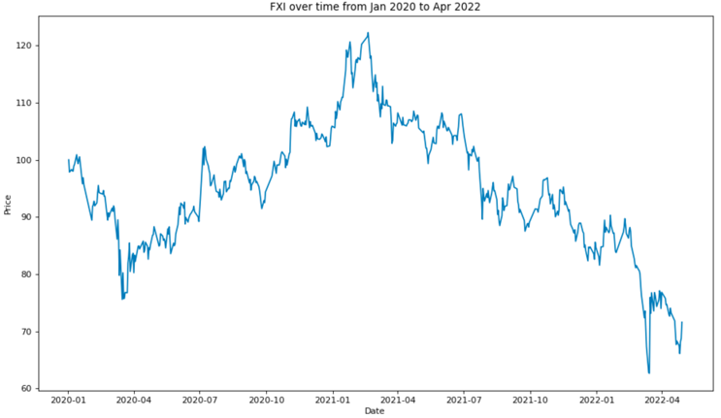

1. A plot of FXI composite index over time with non-stationary data

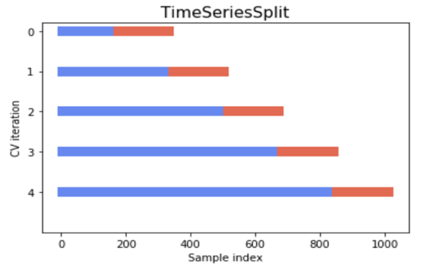

1. Visualization of time series split cross-validation

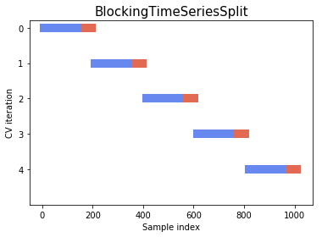

1. Visualization of blocked split cross-validation

**Results for the US Dataset (Nasdaq 100 Index)**

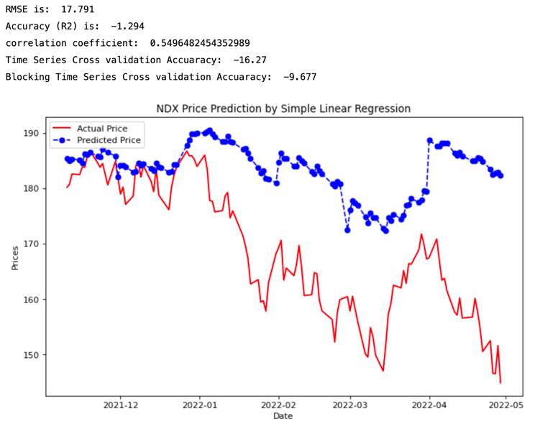

1. Result of Simple Linear Regression in NDX price prediction

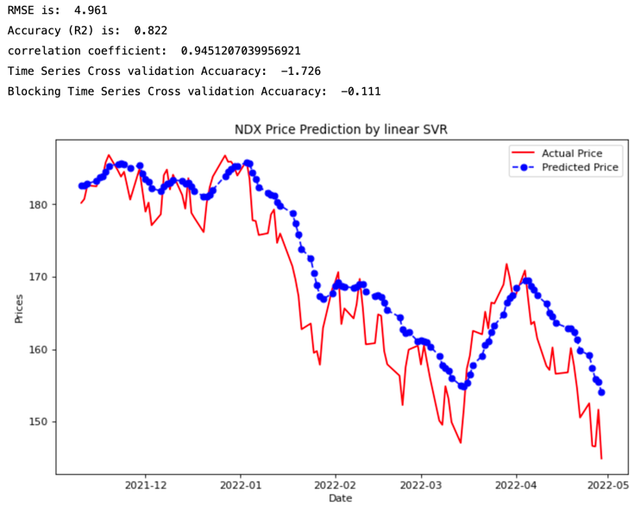

1. Result of SVR with linear kernel in NDX price prediction

**Solely use EMA_10 as an input attribute**

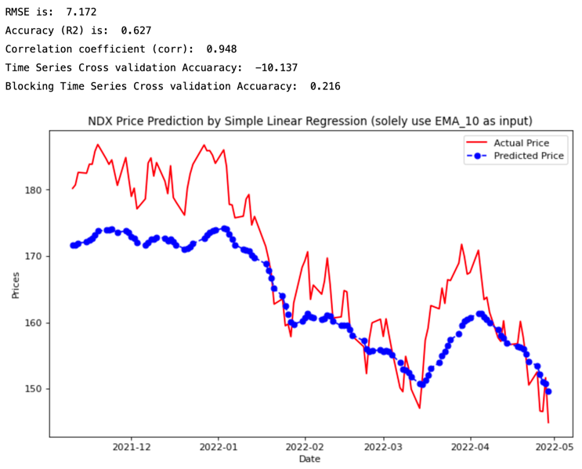

1. Result of Simple Linear Regression when solely using EMA_10 as input

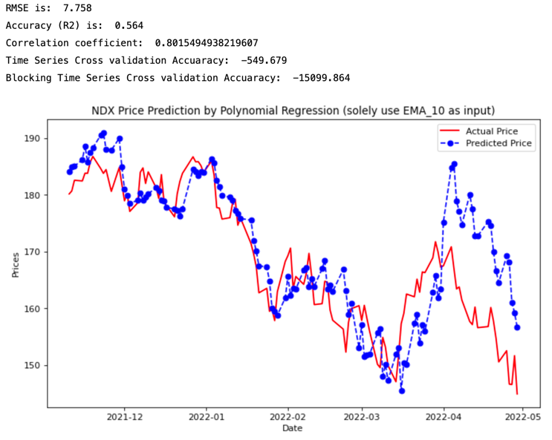

1. Result of Polynomial Regression when solely using EMA_10 as an input attribute

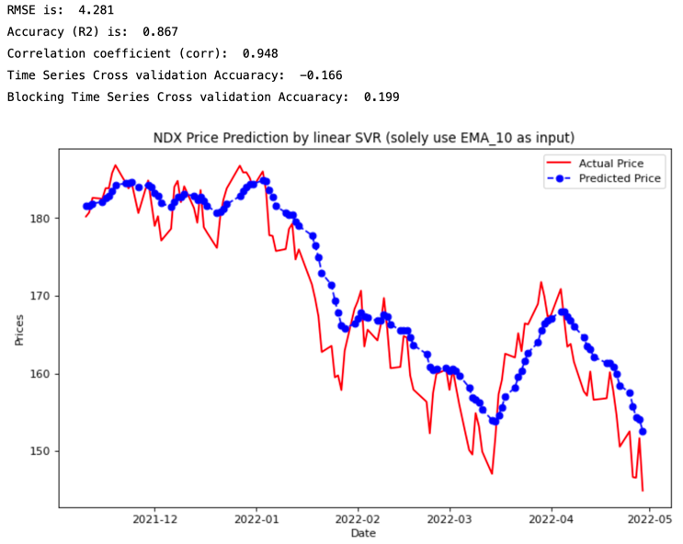

1. Result of linear SVR when solely using EMA_10 as an input attribute

**The results for China Dataset (FXI)**



1. Result of Simple Linear Regression in FXI price prediction

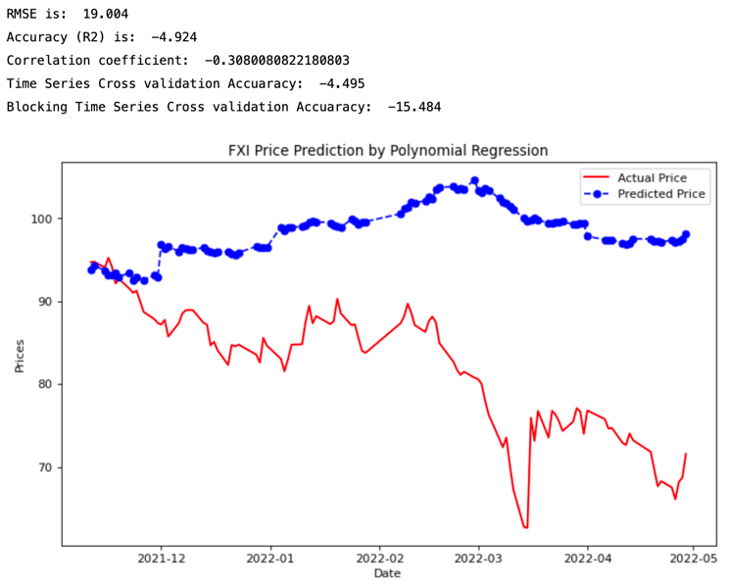

1. Result of Polynomial Regression in FXI price prediction

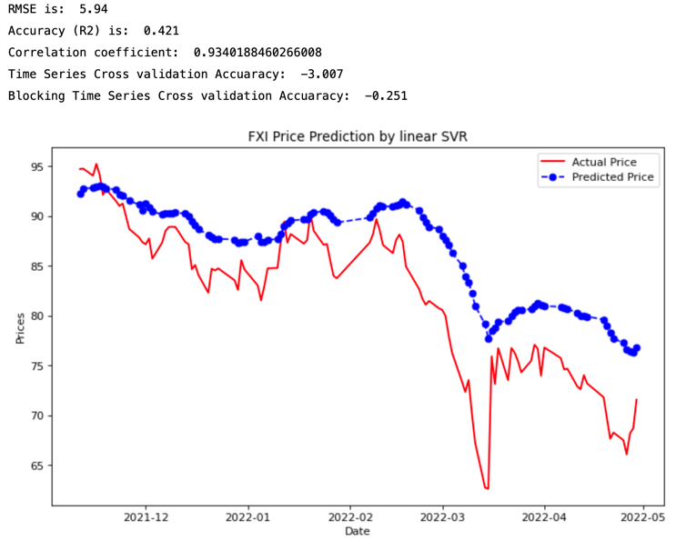

1. Result of Linear SVR in FXI price prediction

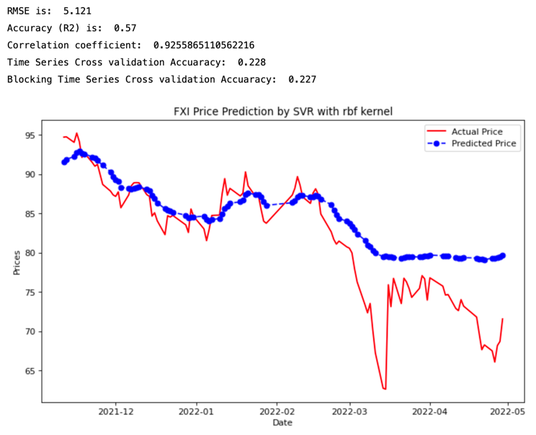

1. Result of SVR with rbf kernel in FXI price prediction

**Appendix D – Graphs of ARIMA Model**

**The US Dataset**

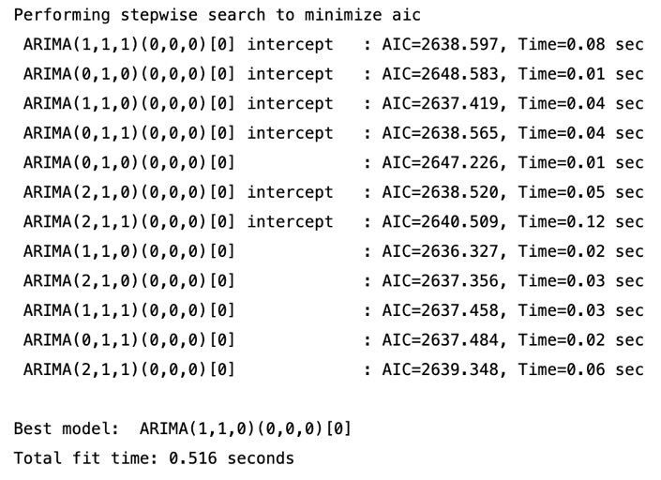

1. Result of using auto_arima to search the best parameters with a stepwise approach in the US dataset

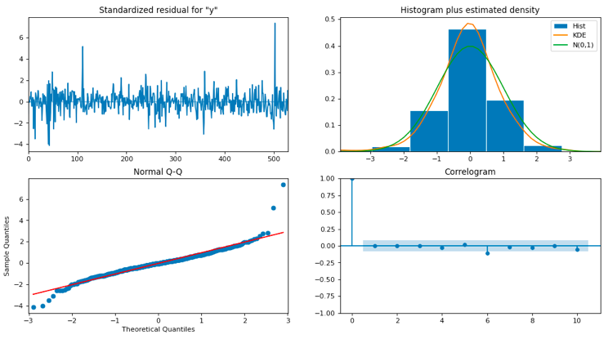

1. Residual plots of the ARIMA model in the US dataset (by calling plot_diagnostics)

**The China Dataset**

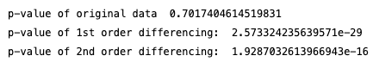

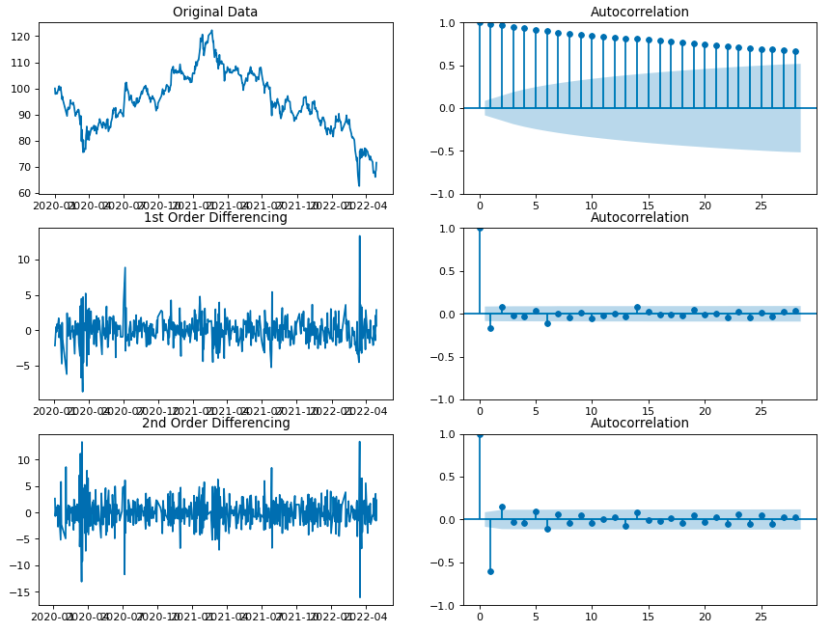

1. Visualisation of data distribution and autocorrelation in original data, 1st order differencing data, and 2nd order differencing data in China dataset

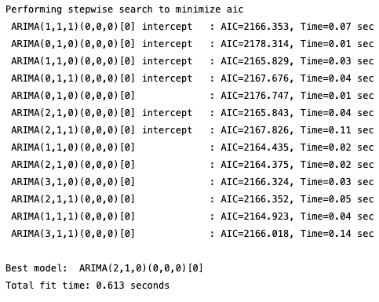

1. Result of using auto_arima to search the best parameters with a stepwise approach in the China dataset

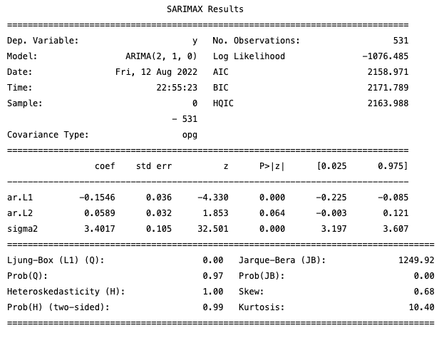

1. A statistic summary of ARIMA result with the parameters (2,1,0) in China dataset

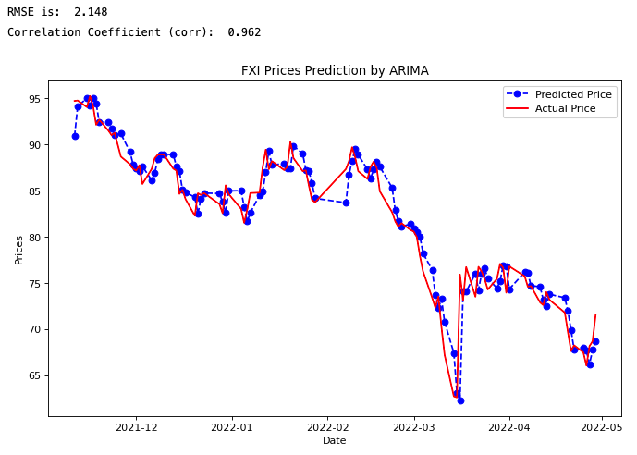

1. The result of the ARIMA model in FXI price prediction

**Appendix E – Coding and notes in Exploratory Analysis**

**Examples of policy and response metrics in OxCGRT**

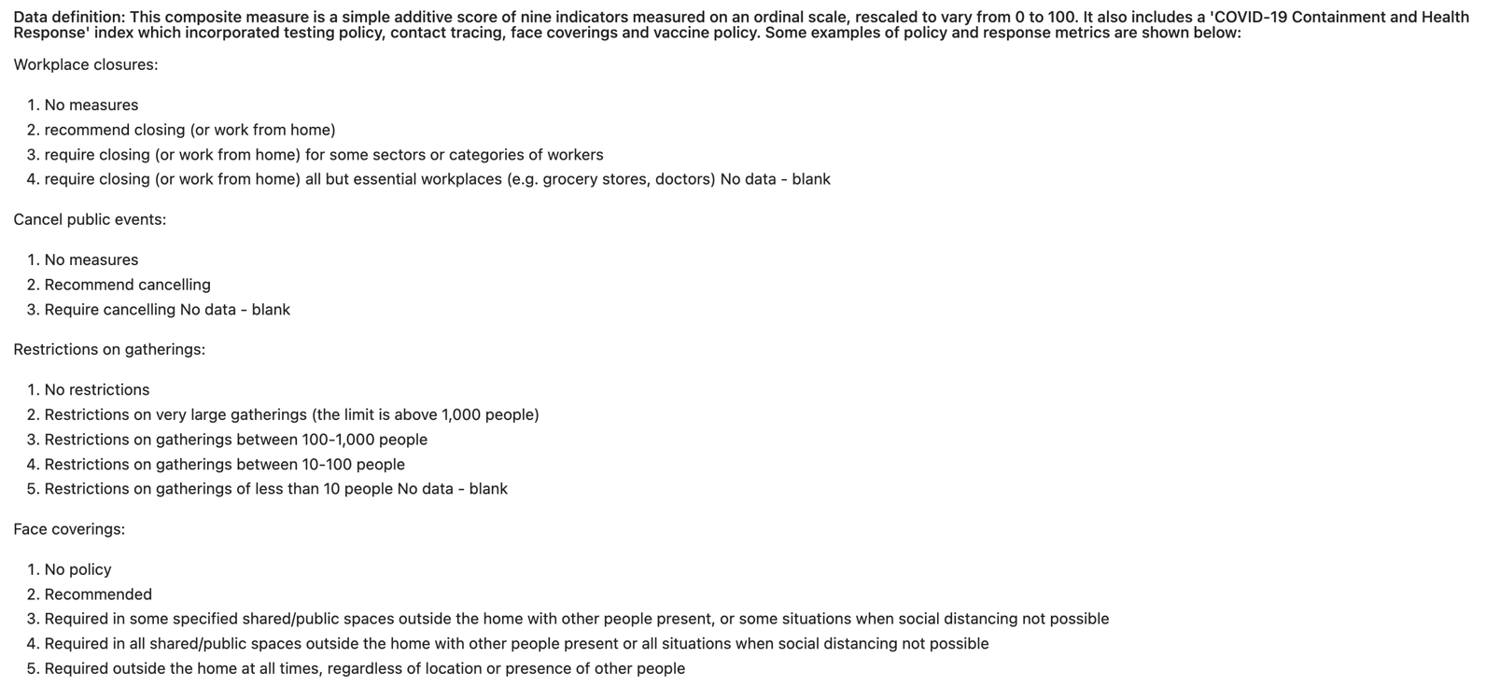

**Codes to import necessary stock data from Yahoo Finance**

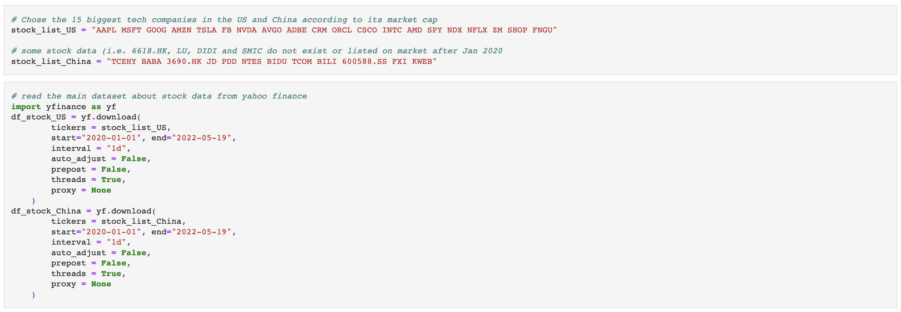

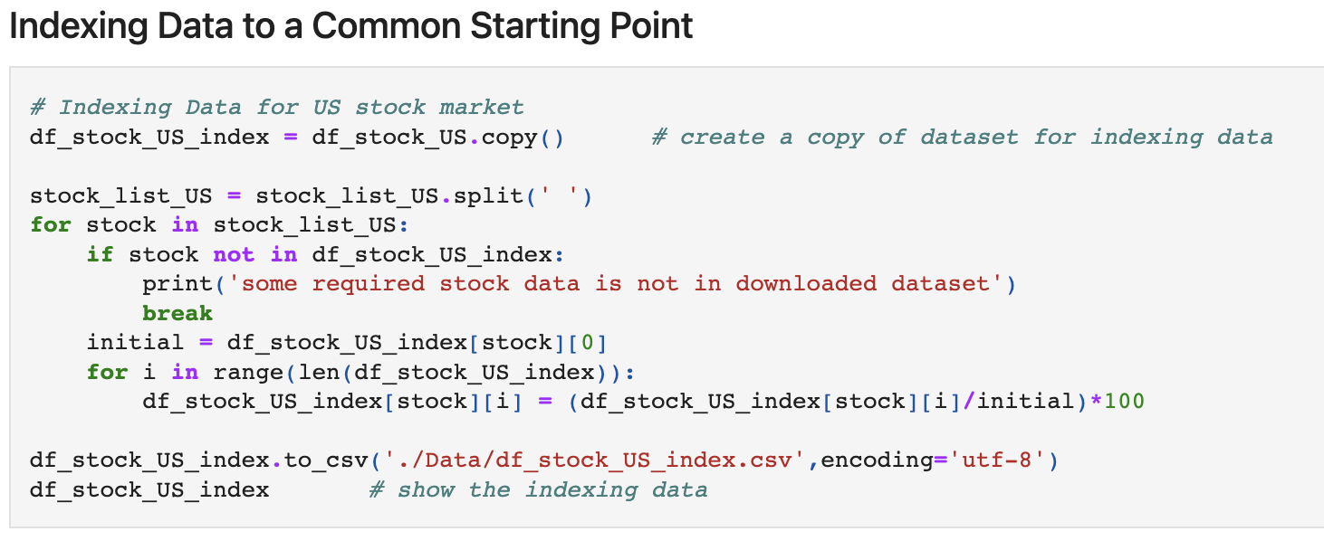

**Codes to plot Figure 5 and 6 (A comparison of COVID-19 new cases and the largest tech stock prices in the US and China from 2020 to 2022)**

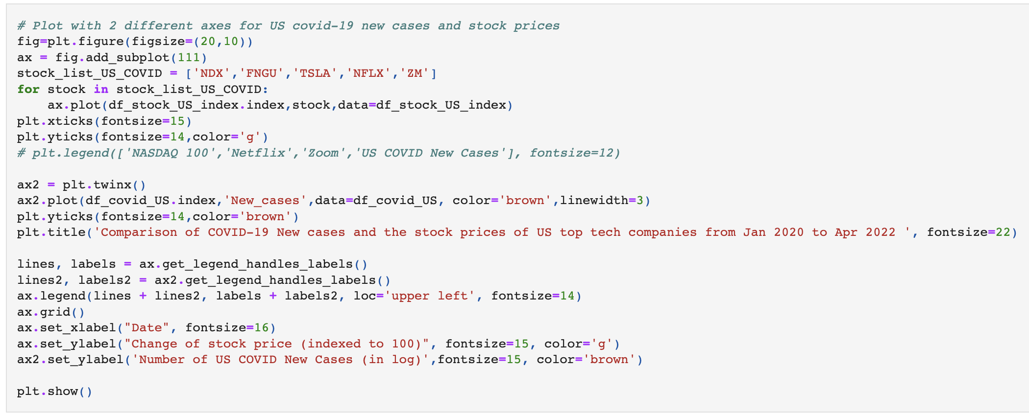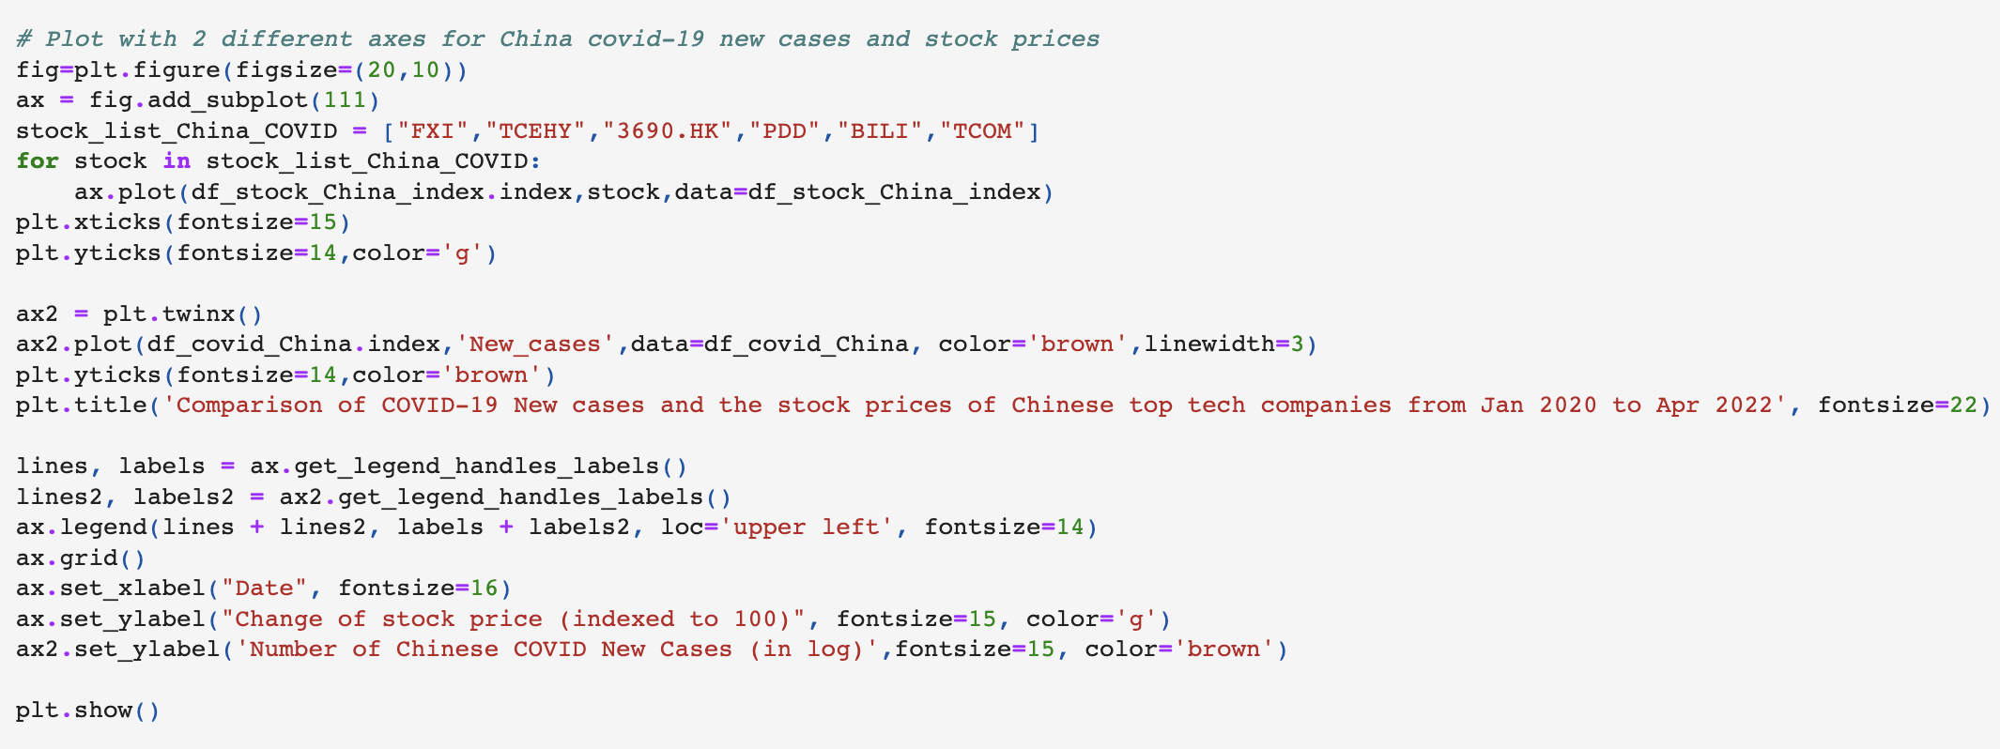

**Codes to plot Figure 7 and 8 (A comparison of the CPI, Unemployment rate and stock prices of US top tech companies from 2020 to 2022)**

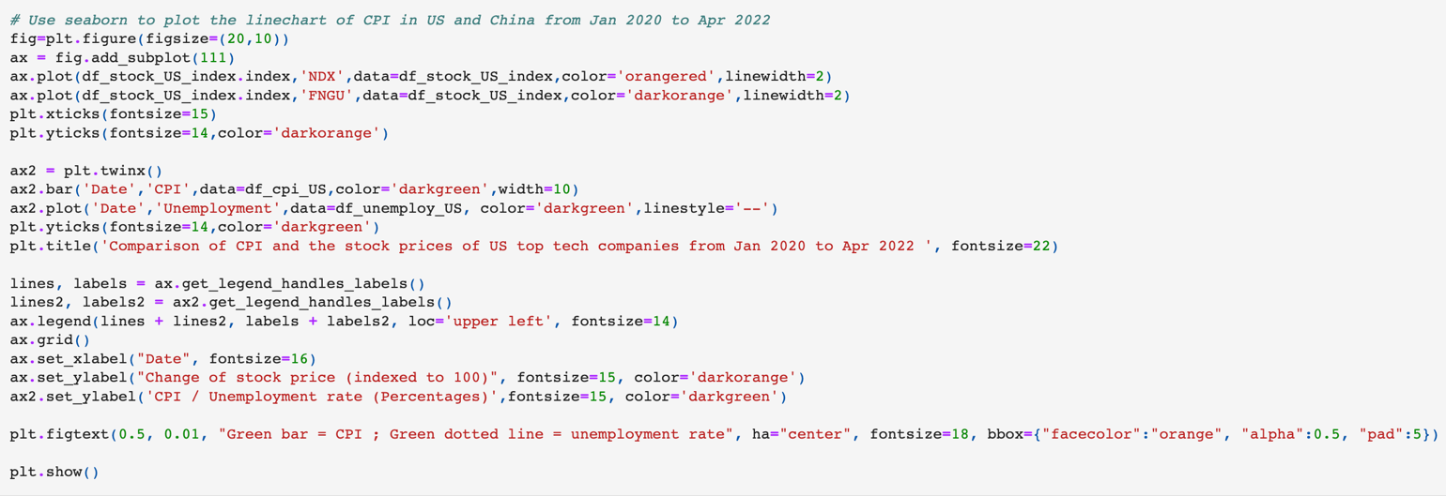

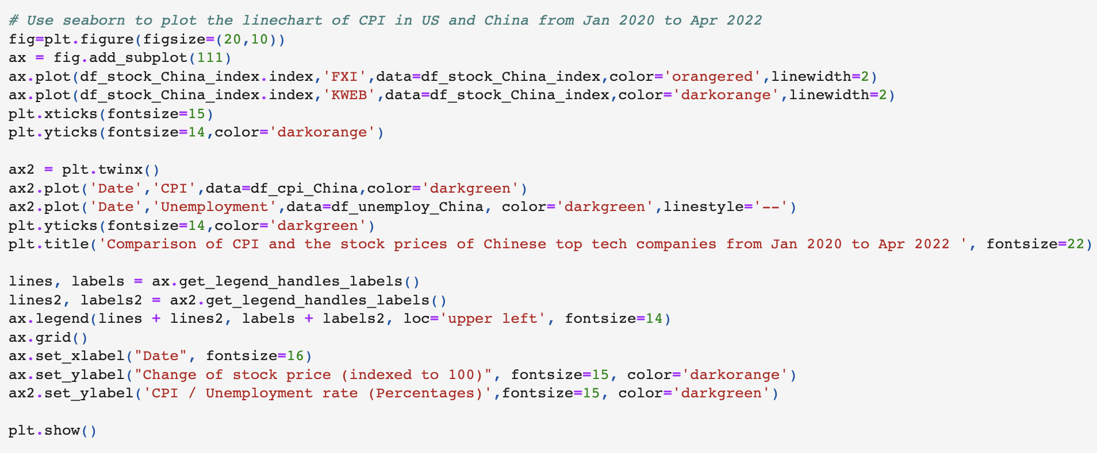

**Codes for Data Merging**

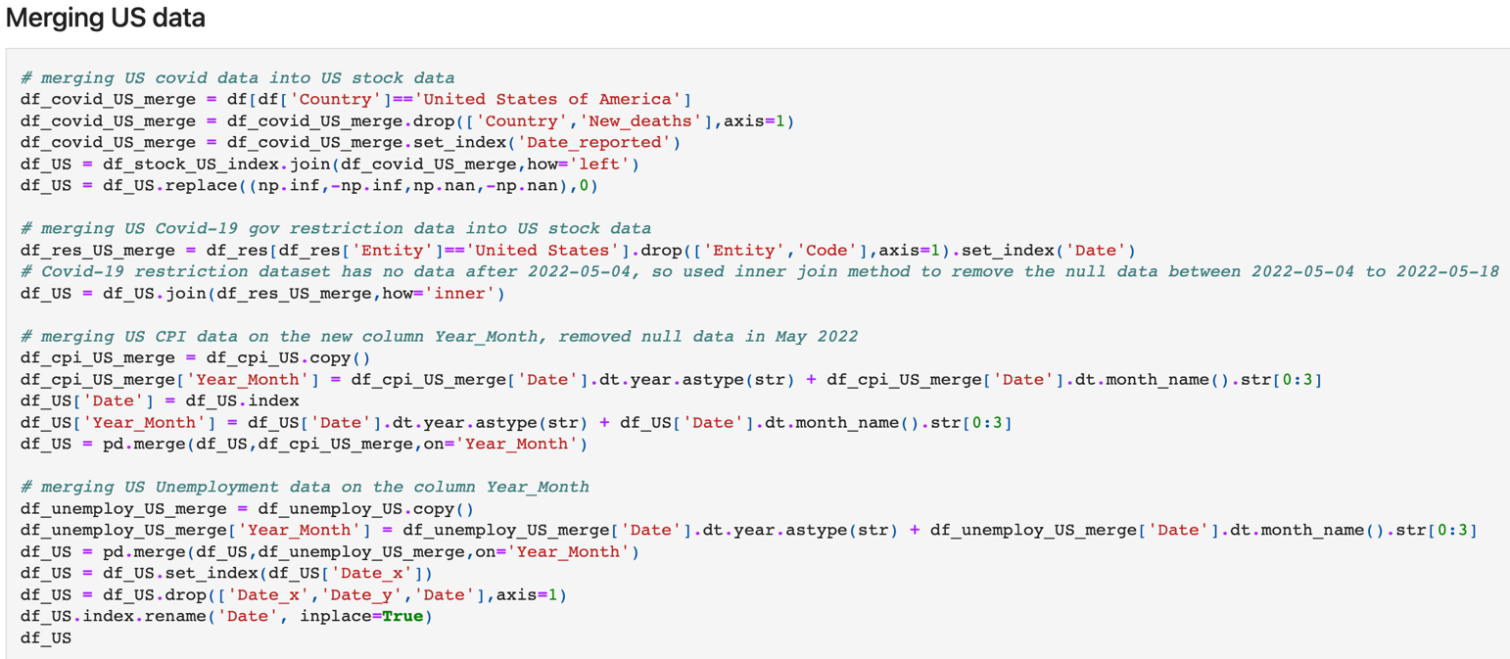

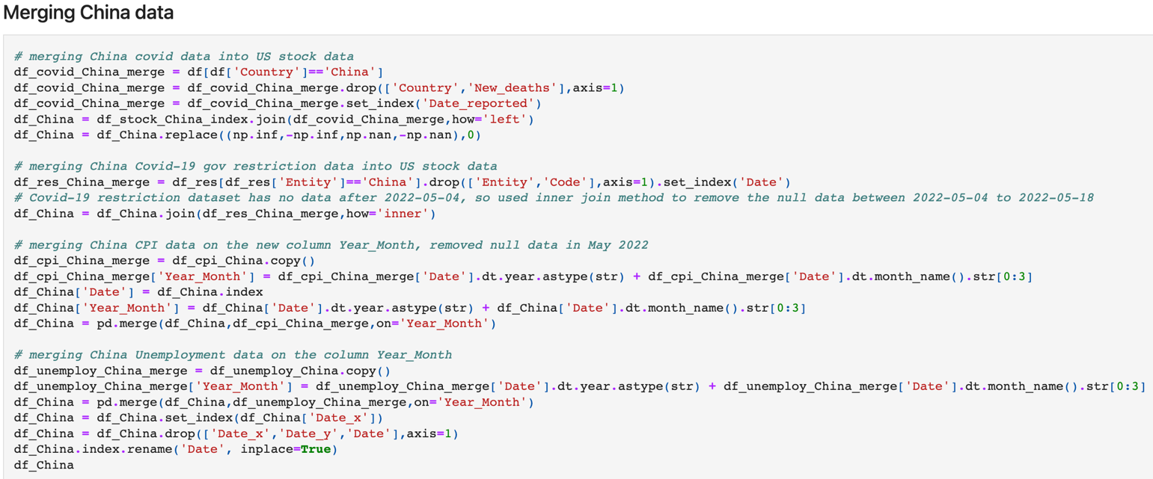

**Appendix F – Coding in Data modelling**

**Codes for the first data modelling - Linear Regression, Polynomial Regression, and SVR** 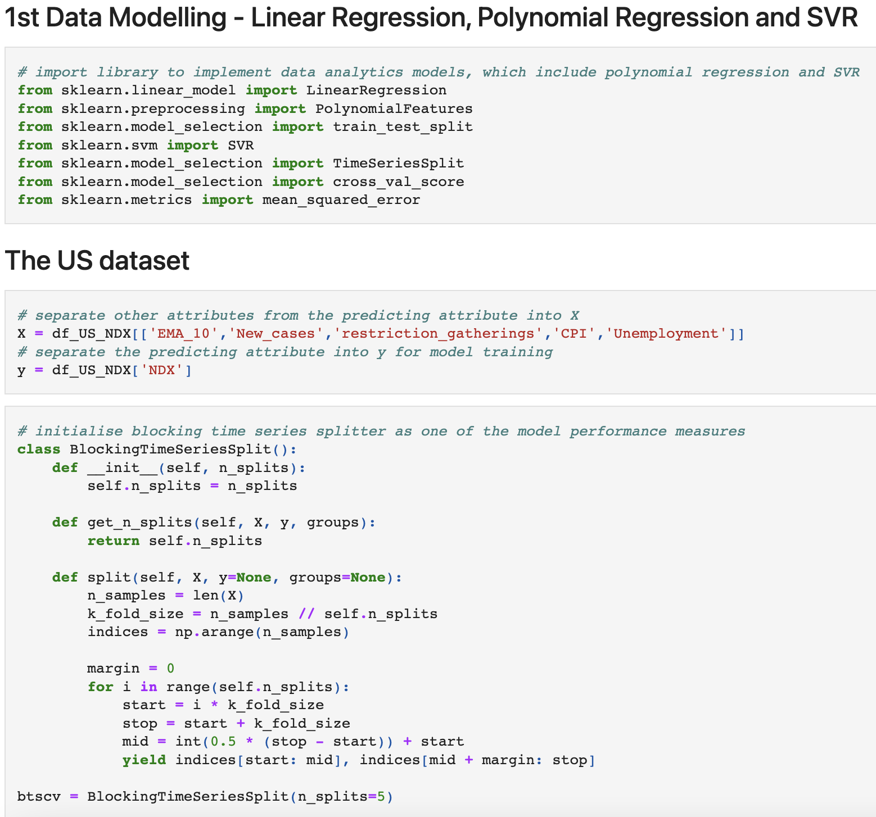

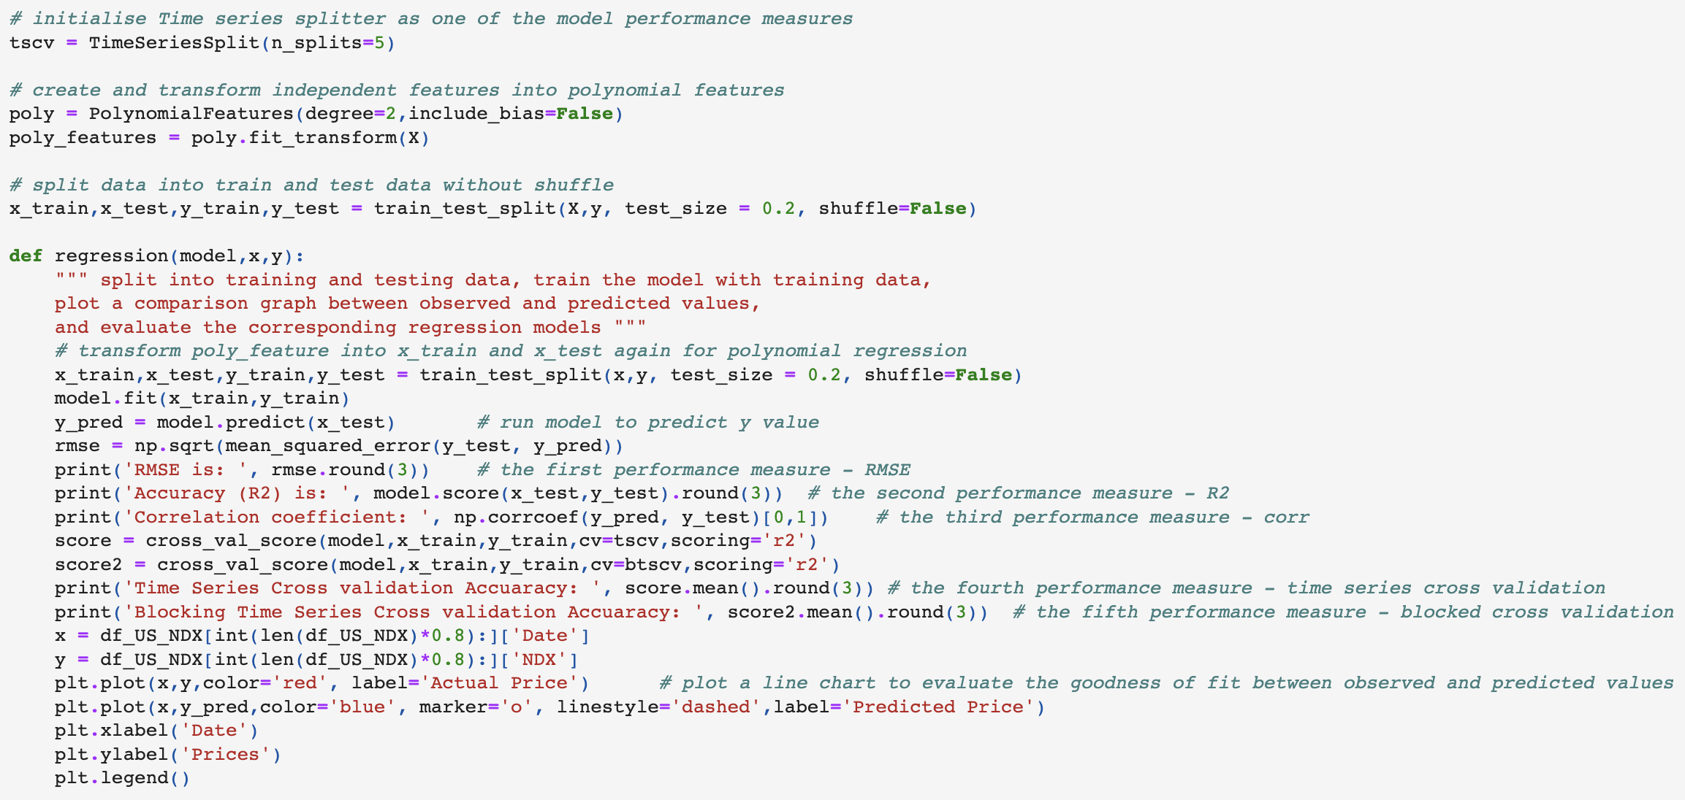

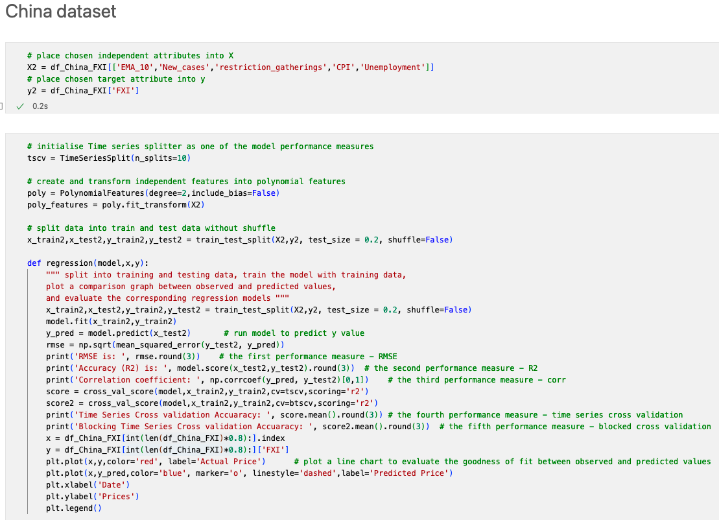

**Codes for the second data modelling – ARIMA model**

